Jayhawks
Non-profit Organization
U.S. Postage
P A I D
JCC
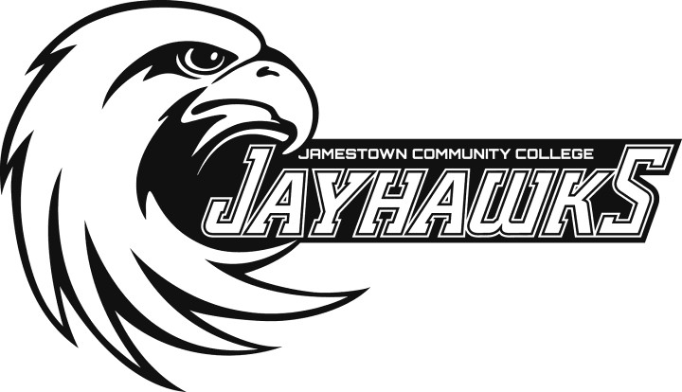
Sports Academies

Registration Form

Name Age Address Grade City State Zip Home phone

Parent’s cell phone

Parent’s e-mail address
T-shirt size (please circle one):
youth small youth medium youth large
adult small adult medium adult large adult extra large

Check camp(s) attending:
July 29-August 1  - Boys’ Basketball | Ages 8-15 | 8 a.m.-noon
 | Cost: $95
August 5-8  - Girls’ Volleyball | Ages 10-15 | 8 a.m.-noon
 | Cost: $95
July 29-August 1  - Elite Volleyball Camp | Ages 15-18 | 5-8 p.m.
 | Cost: $95

Campers are expected to follow camp rules and regulations for health, safety, and rights of all campers. Staff will exercise a reasonable amount of discipline to enforce these rules.

Parents will be notified to take home any camper who infringes on the rights of others. The camper specifically assumes all risks of injury arising out of his/her participation in this program. I grant permission for the use of my child’s photo in camp promotions.
525 Falconer Street
P.O. Box 20
Jamestown, NY 14702-0020

Parent signature Date
2019
Jayhawks Sports Academies

Boys’ Basketball Girls’ Volleyball
Elite Volleyball

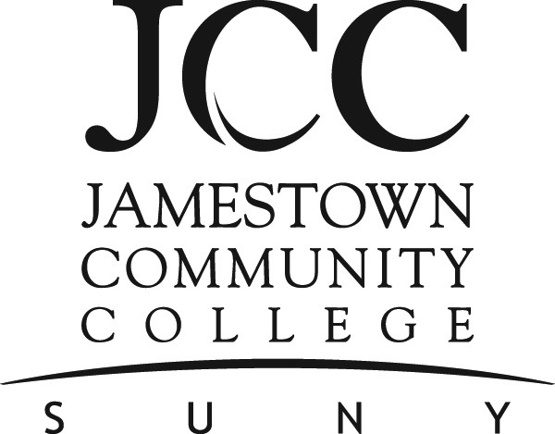

Dear Athletes,
Off season is a great time to improve your skill level and increase your knowledge of sports that interest you. JCC’s 2019 Jayhawks Sports Academies provide the perfect
opportunity to enhance your abilities.

Join our coaching staff and their camp assistants in a week of individual and team
instruction, individual and team competition, and interactive and informative lectures. We provide participants with the opportunity to review and refine current skills, learn new skills, and improve on the talent and desire
they already possess. Development doesn’t
take the summer off!

JCC’s successful professional coaching staff is excited to instruct players at all ability levels. Through a positive coaching philosophy,
personalized motivation, and quality
instruction from our coaches, we help you develop further into the best athlete you can be. If you have any questions regarding any
of our camps, please call me at 716.338.1262.

Consider joining our summer sports academies. We look forward to working with you!

Sincerely,
George Sisson,
Director of Athletics & Recreation

B O Y S ’ B A S K E T B A L L
July 29-August 1 • 8 a.m.-noon • ages 8-15
Director: Xavier Churnac, JCC Basketball Coach
Individual and team concepts of offense, defense,
and special situations will be emphasized.
Introduction into speed, agility, strength, and plyometric jumping.

G I R L S ’ V O L L E Y B A L L

August 5-8 • 8 a.m.-noon • ages 10-15 Director: Brittney Brace, Former JCC & SUNY Brockport Volleyball Player & Current Falconer Coach
Participants will develop individual offensive ball skills in all areas of the game and improve defensive skills in coverage, receiving and
blocking.

E L I T E V O L L E Y B A L L
July 29-August 1 • 5-8 p.m. • ages 15-18
(must have high school JV or varsity experience)
Director: Ashley Lund, JCC Women’s Volleyball Coach
This camp is designed for high school players who want a week of college level intensity in skills, drills, and fundamentals.
Registration Information

Location JCC Physical Education Complex
Bring own equipment (shoes, towel, etc.), snacks, and drinks.

Fee $95 per camper for each camp
($10 discount for additional family member, or additional week of other sports camps). Campers will be grouped according to age, maturity, and general ability.

For more information:
716.338.1262 or 338.1260

Make checks payable to
JCC Faculty Student Association

Send completed application and registration fee(s) to:

Jayhawk Sports Academies Jamestown Community College 525 Falconer Street
P.O. Box 20
Jamestown, NY 14702-0020

Jamestown Community College does not discriminate on the basis of color, sex, sexual orientation, race, creed, religion, national origin or citizenship, age, marital status, military sta- tus, disability, family status, domestic violence victim status, arrest or conviction record, or predisposing genetic character- istics. This policy applies to access to all activities and programs under the college sponsorship as well as to application and selection for admission, employment, and all other personnel procedures within the college.

The college reserves the right, whenever it deems advisable, to change its schedule of tuition and fees; to withdraw, cancel, reschedule, or modify any course, program of study, degree, requirement, or policy.

This material can be made available in alternative media upon request for those with disabilities. Accommodations for those with disabilities can be arranged upon request.

